PSBLOANSIN59MINUTES.COM - INDIAN BANK

Extracted from Bank Admin maker

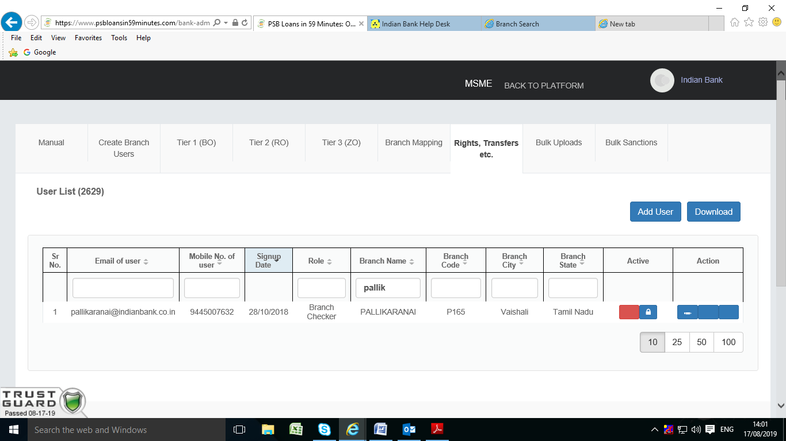

While trying to login with the mobile number of branch user, we are getting following error

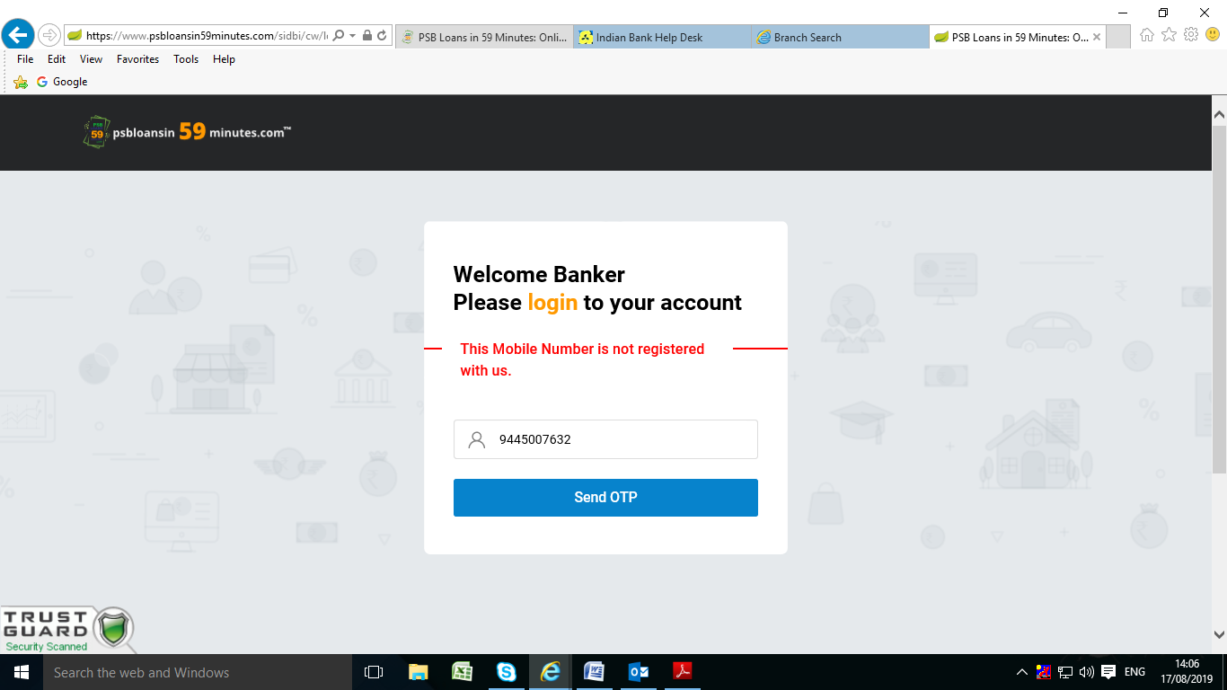

We have reset the password and while trying to login with the email of branch user, we are getting the error: LOGINFAILED.